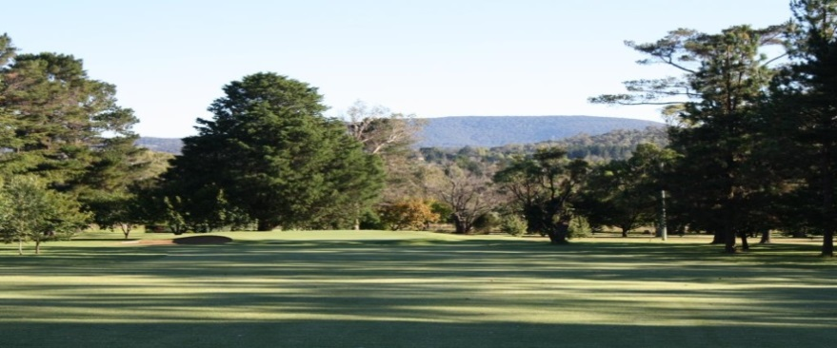

Armidale Golf Club

Application for Membership

I hereby apply for membership to the Armidale Golf Club Limited.
Financial Year ending June 30, 2021.

Name: ________________________________________________________________
Title Surname First Name Second Name

Residential Address: ______________________________________________________

Postal Address: _________________________________________________________
(If different from above)

Date of Birth: _____/_____/________ Mobile Phone: ________________________

Home Phone: ________________ Emergency Contact: _______________

E-Mail: _______________________________________________________________

At times other members may wish to contact you. Do you give permission for Armidale Golf Club
to provide your contact details to other members. YES/NO.

Occupation: ______________________________________________________________________

Name of Employer or Business: ______________________________________________________

Golflink Number: _________________________________________________________________

If not, how long have you been playing golf? ______years. My last handicap was ____________

at __________________________________Golf Club. Par of Course: __________.

If elected, will Armidale be your home club for handicapping purposes? YES/NO.

I wish to become a:
- Golfing Member (Over 21 years of age) $660
- Country/ Full time student Member (resident more than 40 kms or full time student) $165
- Octo Plus membership (80yrs and over)
- Daylight Savings membership (during the months of daylight savings only) $440
- Junior (under 21 years of age) $75
- Cadet Member (12 years of age and under) $5.50
- Social Golfing Member (Discounted Social Green Fees) $220
- Social Member (Allows use of Club House facilities only) $11

I agree to be bound by the Articles of Association of the Armidale Golf Club Ltd and the provisions
of the registered Clubs Act 1976.

Signed: ________________________________________ Date: ____/____/______

Proposed by: ______________________________ Signature: _____________________________
PLEASE PRINT

Seconded by: ______________________________ Signature: ______________________________
PLEASE PRINT

_________________________________________________________________________________
OFFICE USE

Date received: ____/____/______
Paid Subscriptions $______________ Receipt No____________ Date___________

